**Theme:** 2.

**Reading:** Competition and Business Strategy in Historical Perspective.

**Author:** P. Ghemawat.

**1. Historical Background**

Pre 19th C: limited opportunities for business to apply competitive thinking.

-Incentive to stay small

-1850s: Railways: Mass markets.

-Large investments: exploit economies of scale and scope.

Late 19th C: **M-form Corporation:**

Vertically integrated multidivisional

-Invested heavily in manufacturing, marketing, and mgmt structure.

-Began to alter competitive environment.

**2. Formal Approach For Corporate Strategy**

-Alfred Sloan (GM’s CEO) based strategy on S.W.’s of ford.

-Allocating scarce resources in wartime🡪management science innovations.

-New operations🡪research techniques

-Linear programming, devised🡪use of quantitative analysis in strategic planning.

-Learning curves🡪 discovered:

Military aircraft industry: When **Q↑x2 -** labour costs**↓xA%.**

**3. WWII: Changed The Mindset**

-Peter Drucker’s managing 🡪 Responsibility to change your environment as well as yourself to get desired results.

-50/60’s 🡪 MNCs: forced to consider global competition as a factor in planning.

**4. Academic Underpinnings**

· Kenneth Andrews – Harvard professor said– ‘every organization, every sub unit of organization and even every individual ought to have a clearly defined set of purposes or goals which keeps it moving deliberately chosen direction and prevents its drifting in undesired directions.`

· **SWOT** – **S**trengths , **W**eaknesses, **O**pportunities , **T**hreats 🡪 step forward in bringing explicitly competitive thinking to bear on questions of strategy.

· In the 1960’s 🡪 diversification and technological changes increased the complexity of strategic situations

· Harvard Business School said business strategies could only be analysed on a case by case basis in order to account for the unique characteristics of every business 🡪 this led to business’s looking for other standardised approaches to strategy making

· Majority of us companies had set up formal planning departments by 1963

· **PROM** - **PR**ofitability **O**ptimization **M**odel – (used by General Electric(GE)) explained a significant fraction of the variation in the return on investment afforded

· Companies also got help from private consulting firms 🡪 they made contributions in areas such as planning, forecasting, logistics and long range research and development(r&d) 🡪 this section traces their impact on mainstream strategic thinking.

**The rise of strategy consultants**

· Boston Consulting Group(BCG)

· **BCG & The Experience Curve**: Experience Curve 🡪 1965-66 🡪 Bruce Henderson said ‘ it was developed to try and explain price and competitive behaviour in the extremely fast growing segments of industries. i.e. Black and Decker.

· BCG 🡪 standard claim for the experience curve was that for each cumulative doubling of experience, total costs would decline by 20 to 30% due to economies of scale, organisational learning and technological innovation

**From the Experience Curve to Portfolio Analysis**

**B.C.G.’s Growth Share Matrix** 🡪 later known as **Portfolio Analysis**

-Analyse product lines.

¦ ¦ ¦ ¦

¦ ¦ *High Share* ¦ *Low Share* ¦

¦ ¦ ¦ ¦

¦ ¦ ¦ ¦

¦ *High Growth* ¦  **‘Star’** ¦  **‘?’**  ¦

¦ ¦ ¦ ¦

¦ ¦ ¦ ¦

¦ *Slow Growth* ¦ **‘Cash Cow’**  ¦  **‘Dog’**  ¦

¦ ¦ ¦ ¦

· **Mc Kinsey then produced nine block matrix:**

|  |  |  |  |
| --- | --- | --- | --- |
|  | **High Industry Attractiveness** | **Med. Industry Attractiveness** | **Low Industry Attractiveness** |
| **High Business Strength** | *Investment and Growth* | *Selective*  *Growth* | *Selectivity* |
| **Medium Business Strength** | *Selective*  *Growth* | *Selectivity* | *Harvest/*  *Divest* |
| **Low Business Strength** | *Selectivity* | *Harvest/*  *Divest* | *Harvest/*  *Divest* |

· [Problems with The Boston Matrix](http://en.wikipedia.org/w/index.php?title=Problems_with_The_Boston_Matrix&action=edit&redlink=1%20\%20Problems%20with%20The%20Boston%20Matrix%20(page%20does%20not%20exist)). There is an assumption that higher rates of profit are directly related to high rates of market share. This may not always be the case. When Boeing launches a new jet, it may gain a high market share quickly but it still has to cover very high development costs It is normally applied to Strategic Business Units (SBUs). These are areas of the business rather than products. For example, Ford own Land Rover in the UK. This is an SBU not a single product. There is another assumption that SBUs will cooperate. This is not always the case. The main problem is that it oversimplifies a complex set of decision. Be careful. Use the Matrix as a planning tool and always rely on your gut feeling.

· In the 1970’s every major consulting firm used some type of **portfolio analysis** to generate strategy recommendations. Portfolio Analysis gave executives a ready excuse to get rid of poorly performing business units while directing most funds to the ‘stars’ .

· Biggest criticisms on analytical techniques popularized by strategy consultants(Harvard Professors 🡪 They argued that ‘these new principles of management, despite their sophistication and usefulness, encourage a preference for:

**1)** Analytic detachment rather than the insight that comes from hands on experience.

**2)** Short term cost reduction rather than long term development of technological competitiveness.

They said it was a tool that led managers to focus on minimizing financial risks rather than investing in new opportunities that require a long term commitment of resources.

· **Unbundling Industry Attractiveness**

· Joe Bain, Harvard Professor, did two studies on uncovering the general relation between industry structure and performance through empirical work focused on a limited number of structural variables.

**1)** Found that the profitability of manufacturing industries in which the eight largest competitors accounted for more than 70%

**2)** In certain industries ‘established sellers can persistently raise their prices above a competitive level without attracting new firms to the industry. Three basic barriers to entry 🡪 **1)** an absolute cost advantage by an established firm(an enforceable patent for example), **2)** a significant degree of product differentiation, **3)** economies of scale

· His thoughts led to growth of a new subfield of economics – **Industrial Organisation(IO)** 🡪 which explored the structural reasons why some industries were more profitable than others

· Problems of IO🡪 too much focus on public policy rather than business policy (they were concerned too much with the minimization of profits rather than the maximisation of profits,

· Michael Porter, Harvard graduate wrote ***‘note on the structural analysis of industries 1974*’** --> focused on the business policy objective of profit maximization rather than on the public policy objective of profit maximization

· 1980 🡪 competitive strategy - success due to Porter framework for the structural analysis of industry attractiveness

Porter five forces🡪 used a framework not model 🡪 a framework encompasses many variables and seeks to capture much of the complexity of actual competition.

Porter's five forces is a framework for the industry analysis and business strategy development developed by Michael E. Porter of Harvard Business School in 1979. It uses concepts developing, Industrial Organization (IO) economics to derive five forces that determine the competitive intensity and therefore attractiveness of a market. Attractiveness in this context refers to the overall industry profitability. An "unattractive" industry is one where the combination of forces acts to drive down overall profitability. A very unattractive industry would be one approaching "pure competition".

Three of Porter's five forces refer to competition from external sources. The remainders are internal threats. It is useful to use Porter's five forces in conjunction with SWOT analysis (Strengths, Weaknesses, Opportunities, and Threats).

Porter referred to these forces as the micro environment, to contrast it with the more general term macro environment. They consist of those forces close to a company that affect its ability to serve its customers and make a profit. A change in any of the forces normally, requires a business unit to re-assess the marketplace given the overall change in industry information. The overall industry attractiveness does not imply that every firm in the industry will return the same profitability. Firms are able to apply their core competencies, business model or network to achieve a profit above the industry average. A clear example of this is the airline industry. As an industry, profitability is low and yet individual companies, by applying unique business models, have been able to make a return in excess of the industry average.

Porter's five forces include - three forces from 'horizontal' competition: threat of substitute products, the threat of established rivals, and the threat of new entrants; and two forces from 'vertical' competition: the bargaining power of suppliers and the bargaining power of customers.

This five forces analysis is just one part of the complete Porter strategic models. The other elements are the value chain and the generic strategies.

________________________________________________________________________

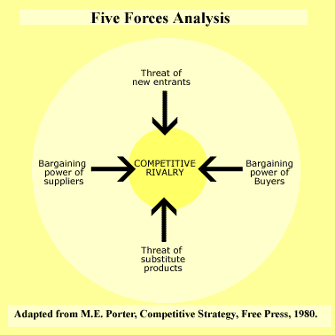

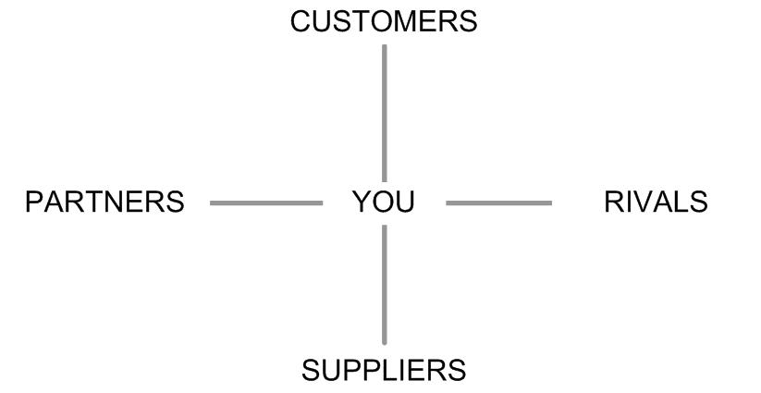

· Adam Brandenburger and Barry Nalebuff 🡪 argued that the process of creating value in the marketplace involved four types of players – customers/suppliers/ competitors and complementors(other firms from which customers buy complementary products and services)

**Competitive dynamics and history:**

· The unsuitability of most competitive advantages was generally thought to reflect **The Red Queen Effect**: the idea that as organizations struggled to adapt to competitive pressures, stronger competitors would emerge, sending the overall level of competition upward and eliminating most, if not all competitive advantages:

· **Game theory:** Game theory is the mathematical study of interactions between players whose payoffs depend on each other’s choices. Game theory models share an emphasis ‘on the dynamics of strategic actions and in particular on the role of complementors.

**Resource based view of the firm:**

· Idea of looking at companies in terms of how much resources they have at their disposal.

· Birger Wernerfelt said : Resource based theorists seek to distinguish their perspective on sustained superior performance from that of IO economics

· They have also tended to see firms stuck with a few key resources, which they must deploy across product markets in ways that maximise total profits rather than profits in individual markets!